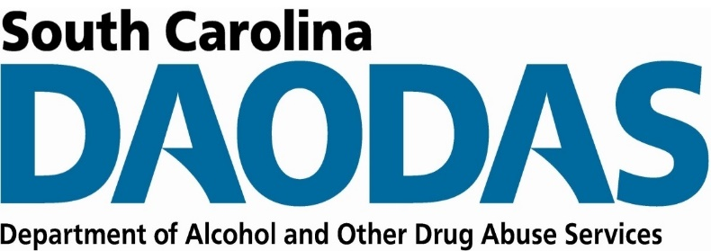
Division of Prevention and Intervention Services
SC DAODAS | 1801 Main Street, 4th Floor, Columbia SC 29201

FY 2022 Prevention SOR 2 Mid-Year Progress Report
ABC Behavioral Health Center Mid-Year Report, October 1, 2021 to March 31, 2022

Strategy Implementation
Instructions: In the table below, please list each Prevention SOR 2 strategy implemented through the mid-year point of the grant period, October 1, 2021 to March 31, 2022. Also identify the population of focus and total number of people reached per strategy. Insert only the “Strategies” and “Specific Strategy Types” that DAODAS has provided.

Strategy | Specific Strategy Type Implemented | Population | Total Number People Reached

Project Narrative

Accomplishments
Instructions: Please share the greatest accomplishments the organization experienced overall.

Challenges
Instructions: Please share the greatest challenges or barriers the organization experienced overall. Indicate how the organization addressed each challenge or barrier.

Additional Comments
Instructions: Please share any additional feedback the organization would like to express.

